Councillor’s Monthly Bulletin – July 2021
from Maurice Cook and Lydia Freeman
(Please circulate electronically and print only when necessary. We should be most grateful for our bulletin to be posted on your websites for the benefit of your residents.)

Ward News
It has been a busy summer.

We are absolutely delighted to welcome the allocation of over £1.1m to a new, purpose built early years school in Dennington for the former Badingham Playgroup. The grant, from District Community Infrastructure Levy was agreed by East Suffolk Cabinet last evening. We sincerely hope that this project will receive all necessary additional support required to bring it to fruition. The approval of this funding demonstrates the commitment of ESC to Framlingham and the surrounding communities to provide the infrastructure needed to support the additional developments which have expanded the community over the last few years.

We are equally delighted that Bruisyard Village Hall has been given the go-ahead to proceed with the creation of an outside terrace on the South side of the hall. This will provide a nice outside space and also provide better and safer egress from Fire exits.
It was good to attend the Well Being event at the Sports Club last week but disappointing that so few attended. In the wake of the pandemic it was good to learn of the many pastoral services available in our community.
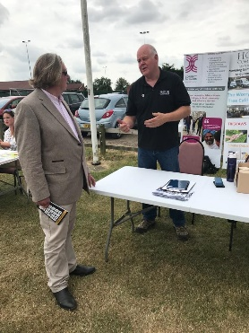
Discussions continue between the Parish Councils of Parham, Marlesford and Gt Glemham in relation to a significant planning application for a solar farm. A joint position has largely been agreed. It would be fair to say that all are mindful of the need for green energy production but, understandably, have concerns about the impact on the local community.
A survey of internet and wifi connectivity in village and community halls across the County is being undertaken. In this post-pandemic world, it is now perhaps expected that community facilities are able to offer wifi connectivity as a part of their offer. Based upon the results of this, Stephen Burroughes and myself will be exploring ways in which we can help improve coverage and further develop a ‘digital by default’ method of conducting local democracy.
The Young People Task & Finish Group of the Framlingham and Wickham Market Community Partnership is to be re-established to review the outcomes of last year’s investments and plan further funding for the future. The small grants scheme is to continue this year for projects of benefit to the community.
Good to attend the Brandeston fete at the weekend. I met some I had only seen as a square box on Zoom!. Great to be out and about meeting for real.

District News
Leisure centre set for further improvements
Waterlane Leisure Centre is set to benefit from further improvements in our leisure facilities.
In April 2021, a £1million refurbishment was completed and the centre is now set for additional works which will see parts of the roof, some of which dates back to 1975, replaced or re-covered.
Starting on 6 September, the
works will be carried out by our development partners, Pulse Design & Build, with completion expected by Easter 2022.

We have worked closely with our operators, Everyone Active, to ensure minimal disruption to customer this work, however, some temporary changes will need to be put in place:

- The soft play area will be closed for around three months when the works start
- The spin studio will be relocated to the old dance studio
- Access to the squash court and group exercise classes will be via the college car park
- The changing village by the pool will be closed for the duration of the works and customers are asked to use the gym changing area during this time;
- However, the gym changing area will be relocated upstairs and there will be no access to showers
Some disruption is also expected in the sports hall, the extent of which will be established once Pulse have further inspected the area.
Changes to garden waste in the south of the district
Rules on what can go into garden waste bins in the south of East Suffolk changed this week (1 September), aligning it with the rest of the district which has had the same arrangements in place for a number of years.

We wrote to every affected household in July explaining what was changing and why, and what can now go into the garden waste bins.

More information on these changes can be found on the FAQs on our Garden Waste page: www.eastsuffolk.gov.uk/waste/waste-collection-and-disposal/garden-waste/

Residents urged to check waste carrier details
Householders in East Suffolk are being reminded of their legal responsibility when disposing of their household waste, after a Suffolk resident was fined over £1,200 at a hearing at Ipswich Magistrates’ Court on Wednesday 18 August.

On 17 March 2020, our Customer Services Team received a report of three black bags of waste which had been left on the verge in Monument Farm Lane, Foxhall. During a site visit the next day, officers from East Suffolk Norse found that the bags contained household waste, including paperwork with a name and address.

When contacted, the individual claimed that the waste was removed from her home address by a third party, along with some scrap items. She was given six weeks to provide details of this person however she did not respond and on 15 May 2020, was issued with a £200 Fixed Penalty Notice, reduced to £120 if paid within 10 days. She failed to pay this notice, despite reminders being sent.

The perpetrator did not attend their court hearing, having written to the court asking for the case to be heard in their absence. The court found them guilty of breaching Section 34(2A) and (6) of the Environmental Protection Act 1990 and fined them £200 for the offence, plus £1,000 for costs and £34 for the victim surcharge, totalling £1,234.

More affordable homes in East Suffolk
More affordable homes are now available to rent in East Suffolk following our purchase of 10 new properties in Nursery Close, Lowestoft from local company Badger Building Ltd.  The homes, comprising six one-bedroom flats and four two-bedroom houses, have | 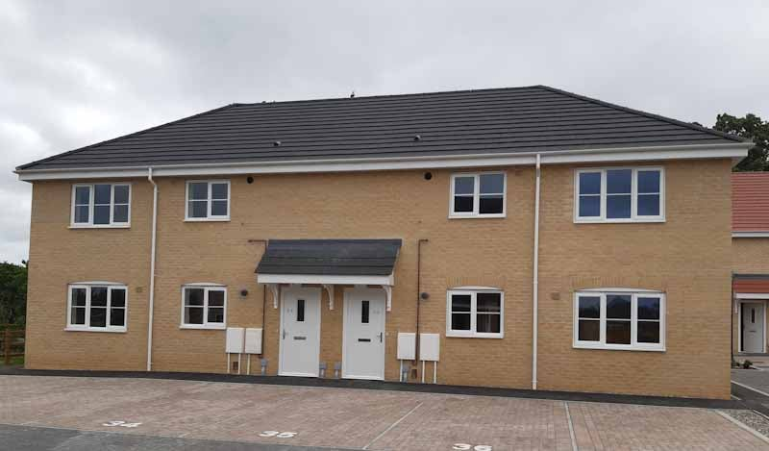
now all been allocated to tenants on our housing register.
These latest homes are part of our programme to deliver vital new housing in East Suffolk for the benefit of local communities and locations which desperately need new, affordable and high-quality housing options.

Suffolk councils supporting Afghan refugees
On Wednesday 18 August, the Government announced its new resettlement scheme for Afghan refugees. Whilst the full details are yet to be confirmed, it is crystal clear that the Government needs local authorities everywhere to step up and support this national effort.

All councils in Suffolk are committed to this cause. We have already helped a small number of Afghan interpreters and their families to resettle in Suffolk, in addition to ongoing work to support unaccompanied asylum seeking children and other refugees entering the UK. In the coming days and weeks, the district, borough and county councils will continue working with the Government to do what we can to provide assistance to vulnerable refugees.

Times like this call for acts of humanity. Suffolk will play its part.

In East Suffolk, accommodation is being offered under the Afghan Relocations and Assistance Policy (ARAP), supporting interpreters who have worked with the British Armed Forces and those who have worked in the British Embassy.

Under this scheme, three people moved into their accommodation in mid-August and are being supported by the Anglia Care Trust to help them integrate into the community and find employment. Further accommodation, both council and privately owned, is being sourced to help as many people as possible.

Felixstowe’s first Triathlon
Individuals and teams of all abilities can now sign up to take part in Felixstowe’s first ever Triathlon – spaces are limited though!

Organised in partnership with Felixstowe Town Council, the triathlon is kicking off on the town’s seafront on Sunday 10 October 2021 at 8am. Open to everyone, whether beginners or experienced athletes, people can now sign up for the Sprint, Supersprint or Standard distance as individuals or teams of three.

The Supersprint will start with a 300m swim in Felixstowe Leisure Centre’s pool whilst the Sprint and Standard will have an open water start with an 800m or 1500m swim. This will be followed by a 20km or 38km bike route through the stunning Suffolk countryside before returning via Felixstowe Ferry to finish with a 3km, 5km or 10km run along the Promenade.

More information, including how to enter, is available at www.felixstowetriathlon.uk/

The Triathlon is part of FelixFest – the ultimate weekend of family fun, which is being hosted to celebrate the Women’s Tour, one of the UK’s biggest sporting events, finishing in Felixstowe this October. See more details at www.eastsuffolk.gov.uk/leisure/womens-tour-and-felixfest/

Further funding boost to local voluntary and community groups
The Carlton Colville, Kessingland, Southwould and surrounding villages Community Partnership opened for the third round of its Small Grant Scheme earlier this week, meaning local voluntary and community groups can once again apply for much-needed funding.

The scheme is aimed at tackling social isolation and loneliness and improving the services available to young people, two of the priorities identified by the Partnership and may support groups and organisations who will be facing challenges post lockdown.

Funding will be available for projects which addresses these and can include activities that can help individuals, groups and families or benefit the wider community, either as a one off or as a series of activities/events, purchasing equipment to support community activity and targeted projects which addresses specific needs linked to the priorities set by the Partnership.

The scheme is open until 5 October 2021 and offers grants of up to £1,500. Full details about eligibility and how to apply can be found at www.eastsuffolk.gov.uk/community/community-partnerships/community-partnership-small-grant-schemes/.
Social media
We keep our communities up to date in a variety of ways and social media has an important role to play. Please follow us and share our posts with your audiences!
Facebook: www.facebook.com/eastsuffolkcouncil
Twitter: https://twitter.com/EastSuffolk

Diary dates

- 6th September: 6pm – Community Partnership Board (Zoom)
- 7th September: 7pm – Cabinet (Riverside)
- 8th September: 4pm - Melton, Woodbridge and Deben Peninsula Community Partnership (Zoom)
- 13th September: 10am – Licensing Sub-Committee (Riverside)
- 13th September: 1.30pm – Licensing Sub-Committee (Riverside)
- 14th September: 2pm – Planning Committee North (Riverside)
- 16th September: 6.30pm – Scrutiny Committee (ESH)
- 20th September: 2pm – Planning Committee South (ESH)
- 20th September: 6pm – Beccles, Bungay, Halesworth and villages Community Partnership (Bungay Community Centre)
- 20th September: 6.30pm – Audit and Governance Committee (ESH)
- 21st September: 11am – Anglia Revenues and Benefits Partnership Joint Committee (Breckland House)
- 21st September: 2pm – Licensing Sub-Committee (Riverside)
- 22nd September: 6.30pm – Full Council (ESH)
- 23rd September: 2pm – Felixstowe Peninsula Community Partnership (Zoom)
- 23rd September: 4pm – Southwold Harbour Management Committee (TBC)
- 27th September: 2pm – Licensing Sub-Committee (ESH)
- 28th September: 2pm – Planning Committee South (ESH)
- 28th September: 6pm – Lowestoft and Northern Parishes Community Partnership (TBC)
- 29th September: 3.30pm – Aldeburgh, Leiston, Saxmundham and villages Community Partnership (Zoom)

